1 Your company "TechStore" needs a small test web server running on Kubernetes.
Requirements:
Create a pod named web-pod
Container image: nginx:latest
Expose port 80

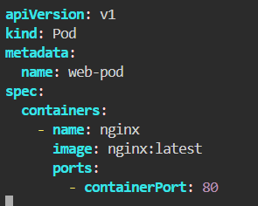
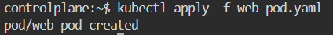

2 The API team wants high availability for their microservice.
Requirements:
Create a ReplicaSet called api-rs
Runs 3 replicas
Image: hashicorp/http-echo
Args: "Hello from API"
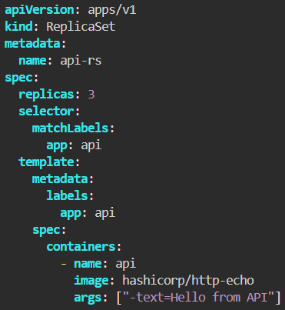
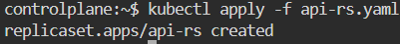

3 You need to create a new environment for QA.
Requirements:
Create a namespace qa
Deploy a deployment called qa-web inside it
Image: nginx:alpine
2 replicas
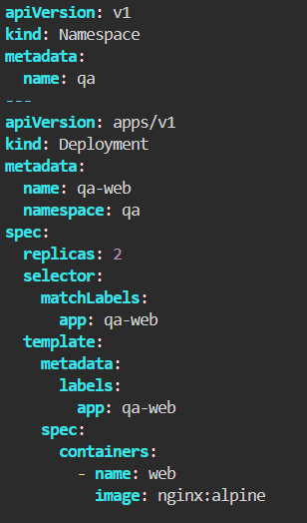
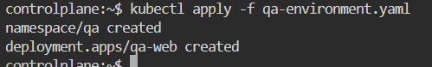

4 A frontend application is unstable and needs resource control and health checks.
Requirements:
Create a Deployment:
Name: frontend
Image: nginx:1.23
Replicas: 2
CPU limit: 200m, request: 100m
Memory limit: 256Mi, request: 128Mi
Liveness probe: http://:80/healthz
Readiness probe: http://:80/ready
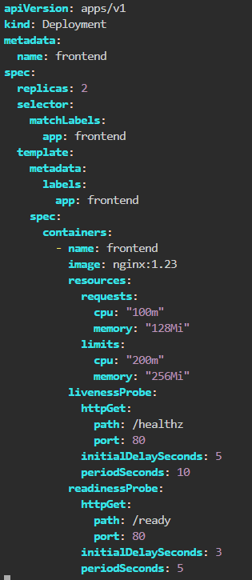
5 A logging app must run only on nodes labeled role=logging.
Requirements:
Use nodeSelector:
key: role
value: logging
Use tolerations for node taint:
node-role=logging:NoSchedule
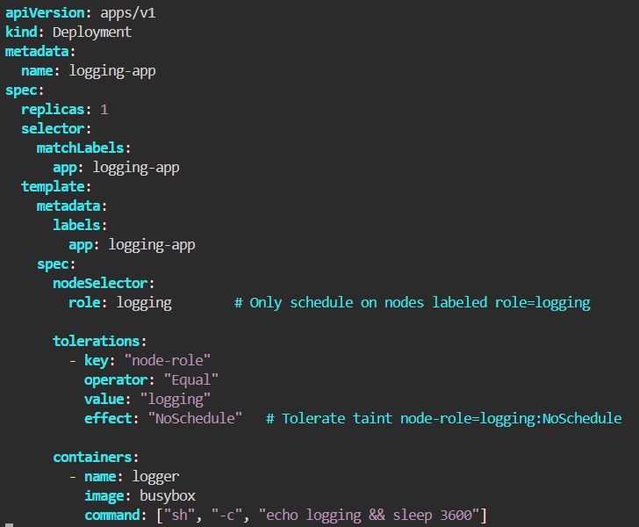
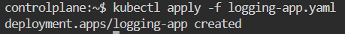
6 Expose a backend service within the cluster.
Requirements:
Create:
Deployment: backend
Image: python:3.9-slim
Container port: 5000
ClusterIP service: backend-service → port 80 → targetPort 5000
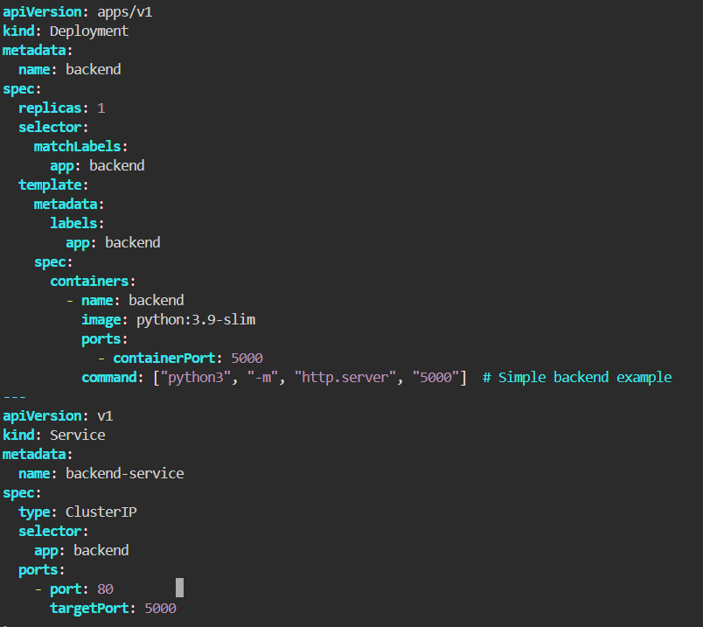
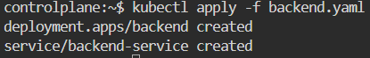
7 Your app needs a DB password stored securely.
Requirements:
Create a secret named db-secret containing DB_PASSWORD=pass123
Deployment using the secret as env var
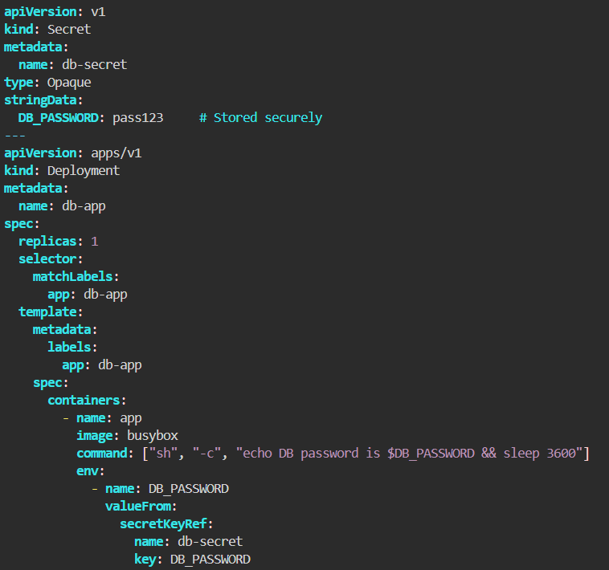
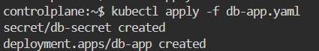

8 A service needs to download initial data before starting.
Requirements:
Init container downloads data to /data
Main container serves it using nginx
Use an emptyDir volume
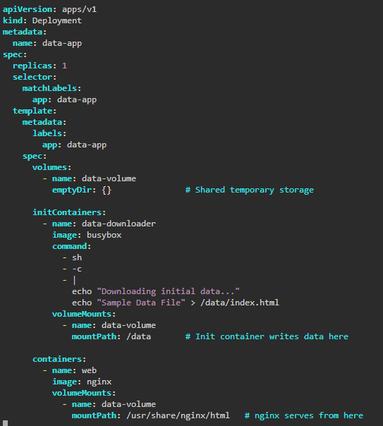

9 Deploy a Redis cluster requiring stable storage and stable network identity.
Requirements:
StatefulSet redis-db
3 replicas
VolumeClaimTemplate for /data
Headless service: redis
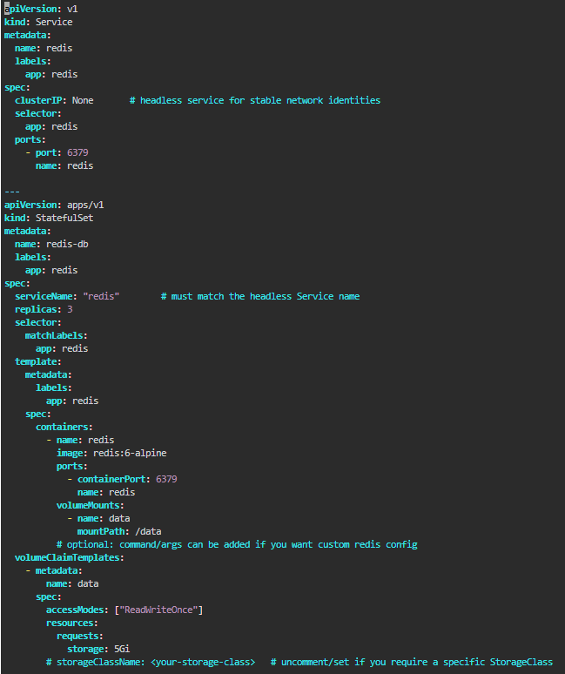
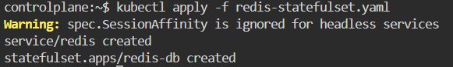
We use clusterIP: None because:
- It creates a headless service
- A headless service provides stable DNS names
- Stable DNS names are required for StatefulSets
- Without it, StatefulSet networking does not work correctly
Why the warning appears
• Does not have a cluster IP
• Does not perform load-balancing
• Simply returns pod IPs directly (used by StatefulSets for stable DNS names)

10 A batch job must run once to process monthly reports.
Requirements:
Job name: report-generator
Image: bash
Command: echo "Report generation done"
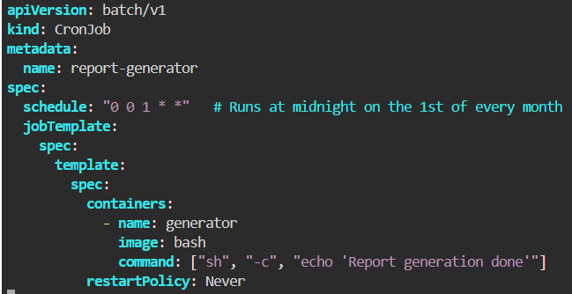

11 Run a cleanup script every day at 2 AM.
Requirements:
CronJob name: daily-cleanup
Schedule: "0 2 * * *"
Image: alpine
Command: rm -rf /tmp/*
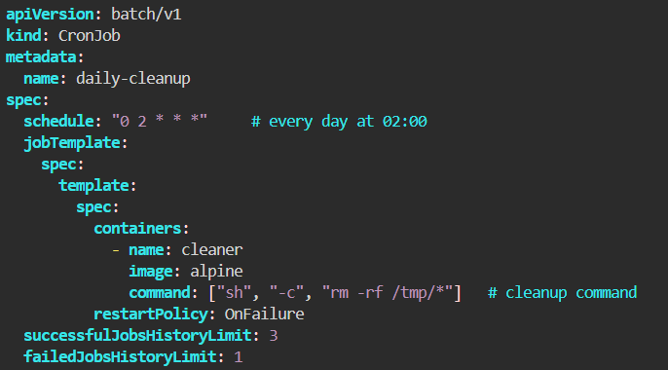
12 A monitoring agent must always run on every master node as a static pod.
Requirements:
Pod name: monitor-agent
Image: busybox
Location: /etc/kubernetes/manifests/
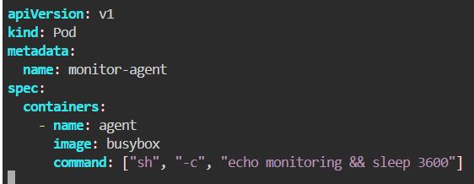
13 A node-level log collector must run everywhere.
Requirements:
DaemonSet name: node-logger
Image: fluent/fluent-bit
Mount /var/log
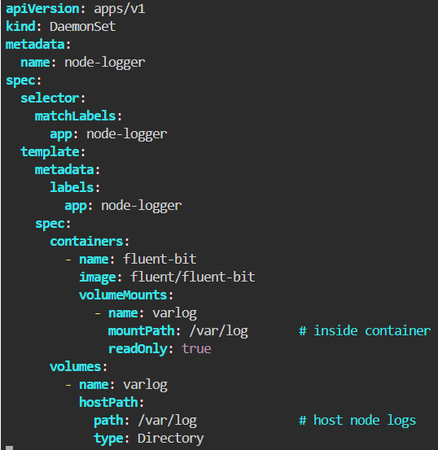
14 Only the frontend app should access the backend.
Requirements:
Allow ingress only from pods with label app=frontend
Deny all else
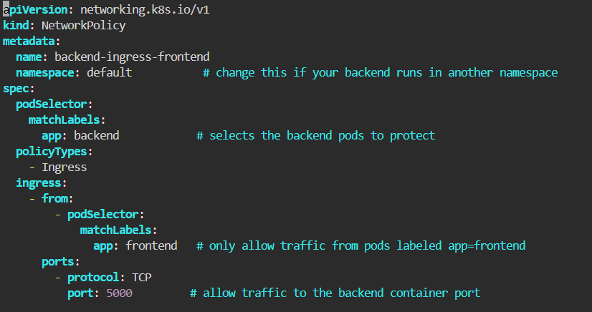
15 Give a support engineer read-only access to pods in namespace support
Requirements:
Role: support-read
Permissions: GET/LIST/WATCH pods
RoleBinding binding user support-user
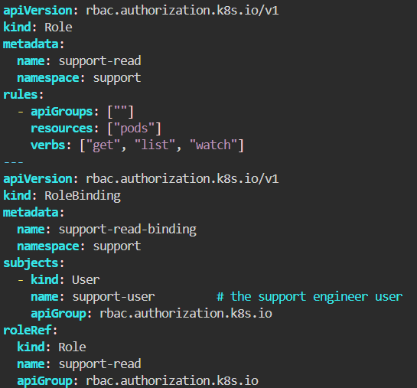
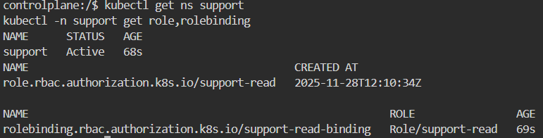

16 Students must verify and describe how pods communicate through the installed CNI.
Requirements:
Deploy a test pod
Run connectivity tests between nodes
Document CNI behavior (Calico/Flannel/Cilium…)
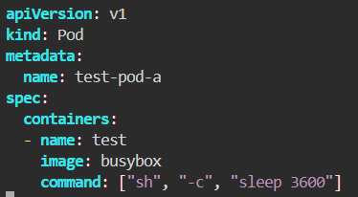
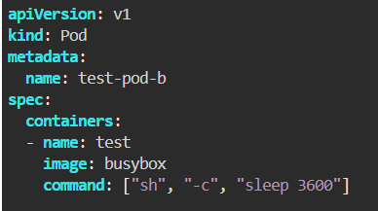
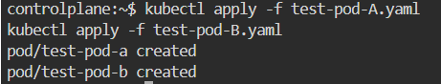
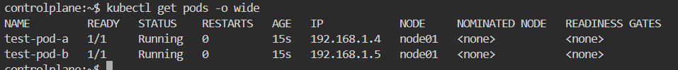
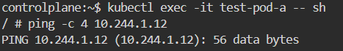
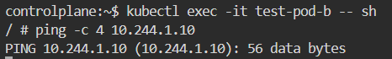
CNI Installed: Calico
Pod-to-pod communication: Successful (ping works between Pod A and Pod B).
Explanation:
Calico assigns each pod its own routable IP address. Pods communicate across nodes using Calico-managed routing.
17 Expose two applications under the same domain:
app1 → /app1
app2 → /app2
Requirements:
Two deployments
Two services
Ingress:
host: apps.example.com
path-based routing
